**STP with EtherChannel in Cisco Packet Tracer**

**Project Description:**

This project demonstrates how to configure Spanning Tree Protocol (STP) to prevent Layer 2 loops and implement EtherChannel (LACP) between switches for link aggregation and redundancy in a small enterprise network using Cisco Packet Tracer.

**Objectives:**

* Simulate an enterprise network topology with multiple redundant paths.
* Configure EtherChannel (LACP) between switches for bandwidth enhancement.
* Enable STP to ensure loop-free topology and failover handling.
* Verify link status and spanning-tree behavior using Cisco CLI.

**Network Devices Used:**

* **3 Cisco 2960 Switches** (SW1, SW2, SW3)
* **2 End Devices (PC1, PC2)**
* **Copper Straight-Through Cables**

**Network Topology**:

**Interface Mapping:**

| **Connection** | **Device A - Interface** | **Device B - Interface** |
| --- | --- | --- |
| PC1 ↔ SW1 | PC1 - Fa0 ↔ SW1 - Fa0/5 |  |
| PC2 ↔ SW2 | PC2 - Fa0 ↔ SW2 - Fa0/5 |  |
| SW1 ↔ SW2 | Fa0/1, Fa0/2 | Fa0/1, Fa0/2 |
| SW1 ↔ SW3 | Fa0/3, Fa0/4 | Fa0/1, Fa0/2 |
| SW2 ↔ SW3 | Fa0/3, Fa0/4 | Fa0/3, Fa0/4 |

**Output:**

**On SW1:**

**On SW2:**

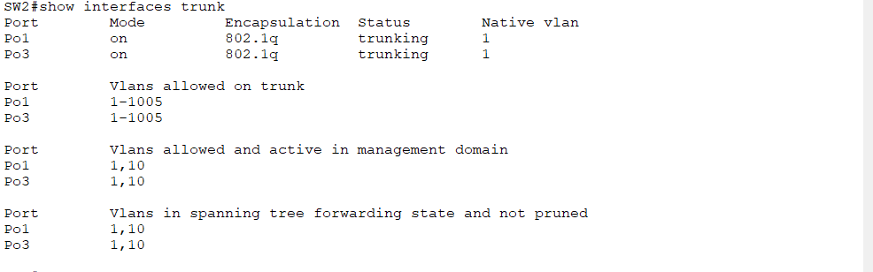

**On SW3:**

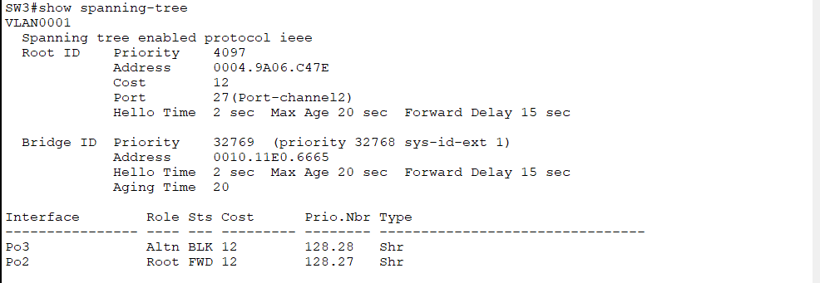

**Expected Behavior:**

* One link will be blocked by STP to prevent loops.
* If an active link fails, STP re-converges and activates the blocked port.
* EtherChannel combines bandwidth and provides redundancy.